Experiment 7
Columnar Transposition Cipher

Aim
To implement the Columnar Transposition Cipher using Python.

Algorithm
Read the plaintext and keyword.
Arrange the text in rows.
Order columns according to the keyword.
Read the columns in sorted order.
Display the encrypted text.

Code:
key = input("Enter Key: ")
plaintext = input("Enter Plain Text: ").replace(" ", "").upper()
cols = len(key)
rows = len(plaintext) // cols
if len(plaintext) % cols != 0:
rows += 1
while len(plaintext) < rows * cols:
plaintext += "X"
matrix = []
k = 0
for i in range(rows):
row = []
for j in range(cols):
row.append(plaintext[k])
k += 1
matrix.append(row)
order = sorted(range(len(key)), key=lambda x: key[x])
encrypted = ""
for i in order:
for j in range(rows):
encrypted += matrix[j][i]
decrypt_matrix = [["" for i in range(cols)] for j in range(rows)]
k = 0
for i in order:
for j in range(rows):
decrypt_matrix[j][i] = encrypted[k]
k += 1
decrypted = ""
for i in range(rows):
for j in range(cols):
decrypted += decrypt_matrix[i][j]
print("Encrypted Text:", encrypted)
print("Decrypted Text:", decrypted)

Output:
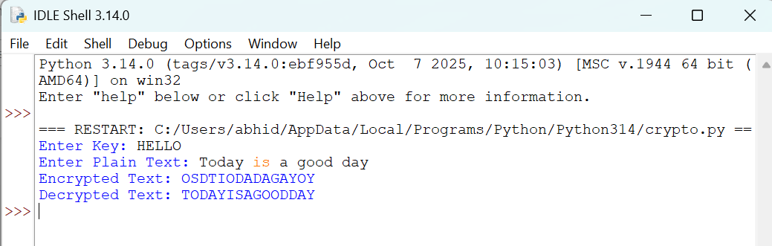

Result:
Thus, the Columnar Transposition Cipher was implemented successfully
using Python.

